DATA PREPROCESSING PROJECT REPORT
Women's Clothing: Trends and Analysis
in the Fashion Industry
Normalization and Scaling of Numerical Features
FINAL DECISION MinMaxScaler was selected as the best required scaling technique; the unscaled feature set remained the strongest overall baseline.

Executive Summary
This report documents the testing and selection of a numerical feature-scaling method for the Women's Clothing: Trends and Analysis in the Fashion Industry project. Four required techniques - MinMaxScaler, StandardScaler, RobustScaler, and PowerTransformer - were evaluated on Age and Positive Feedback Count. The analysis considered distribution behavior, skewness, sensitivity to extreme observations, held-out KNN classification performance, and five-fold stratified cross-validation.
The unscaled feature set produced the highest overall cross-validation weighted F1 result and was retained as a baseline. After excluding that baseline and comparing only the four required scaling techniques, MinMaxScaler produced the best observed model-performance result. It was therefore selected for the final export. The final scaled features lie within the 0-1 interval, while all non-scaled columns and the dataset dimensions remain unchanged.
KEY RESULT The task is complete: MinMaxScaler was selected, applied to the two eligible features, and validated without introducing missing or infinite values.

1. Project Context and Objective
Feature scaling is necessary when numerical variables use different units or ranges, particularly for distance-based algorithms such as K-Nearest Neighbors. Without scaling, a feature with a wider numerical range can dominate distance calculations even when it is not more informative.
The objective was to test multiple scaling techniques, preserve useful distributional information, evaluate the effect on model performance, and select a defensible final method. Selection was based on evidence rather than choosing a scaler in advance.

2. Dataset Profile
The analysis used the Women's E-Commerce Clothing Reviews dataset. It contains customer-review, product-category, rating, recommendation, age, and positive-feedback information. The supplied CSV was read successfully before any transformation was performed.
Item | Details
Source | Kaggle - Women's E-Commerce Clothing Reviews
Source URL | https://www.kaggle.com/datasets/nicapotato/womens-ecommerce-clothing-reviews
Observations | 23,486
Columns | 11
Input features | Age; Positive Feedback Count
Target | Recommended IND (0 = not recommended, 1 = recommended)
Train/test split | 80% / 20%, random_state=42, stratified by target

2.1 Feature eligibility
Column | Decision | Rationale
Age | Scale | Continuous numerical feature measured in years.
Positive Feedback Count | Scale | Count feature with a wide, right-skewed range.
Clothing ID | Exclude | Product identifier; numerical appearance does not make it a measurement.
Rating | Exclude | Ordinal score already restricted to the 1-5 scale.
Recommended IND | Target | Binary outcome used for classifier evaluation.
no | Exclude | Row/index field with no predictive meaning.

3. Exploratory Distribution Analysis
Baseline distribution analysis was completed before scaling so that subsequent changes could be interpreted correctly. Summary statistics, histograms, kernel-density curves, boxplots, skewness, and IQR-based potential outlier counts were reviewed.
Feature | Mean | Std. | Min | Median | Max | Skew | IQR outliers
Age | 43.20 | 12.28 | 18 | 41 | 99 | 0.526 | 109
Positive Feedback Count | 2.54 | 5.70 | 0 | 1 | 122 | 6.473 | 2,147
Age showed moderate positive skewness. Positive Feedback Count was extremely right-skewed: most reviews received little or no positive feedback, while a small number received unusually high counts. This difference made the dataset suitable for comparing linear scaling with a nonlinear power transformation.

4. Methods Tested
Technique | Operation | Expected behavior
MinMaxScaler | Maps training minimum and maximum to 0 and 1. | Preserves distribution shape; sensitive to extremes.
StandardScaler | Centers on mean 0 and standard deviation 1. | Preserves shape; affected by extreme values.
RobustScaler | Centers on median and scales by the IQR. | Preserves shape; reduces outlier influence.
PowerTransformer | Applies Yeo-Johnson and standardization. | Reduces skewness; intentionally changes shape.

4.1 Leakage-safe implementation
The dataset was split before fitting any scaler. Each scaler learned its parameters only from the training data, and the fitted object was then used to transform the held-out test data. Cross-validation used a Pipeline so that the scaler was refitted independently inside every fold. This prevents test or validation information from influencing preprocessing.
CORRECT ORDER Split data -> fit scaler on training partition -> transform training and test partitions -> train and evaluate the model.

5. Statistical Comparison
Min-Max, Standard, and Robust scaling are linear transformations. They alter location and scale but retain the basic distribution shape and skewness. PowerTransformer is nonlinear and was specifically included to reduce asymmetry.

5.1 Interpretation
PowerTransformer achieved the strongest symmetry improvement, reducing Age skewness to approximately zero and Positive Feedback Count skewness to a much smaller positive value. However, the project objective required both distribution considerations and model performance. A statistically more symmetric representation is not automatically the best predictive representation.
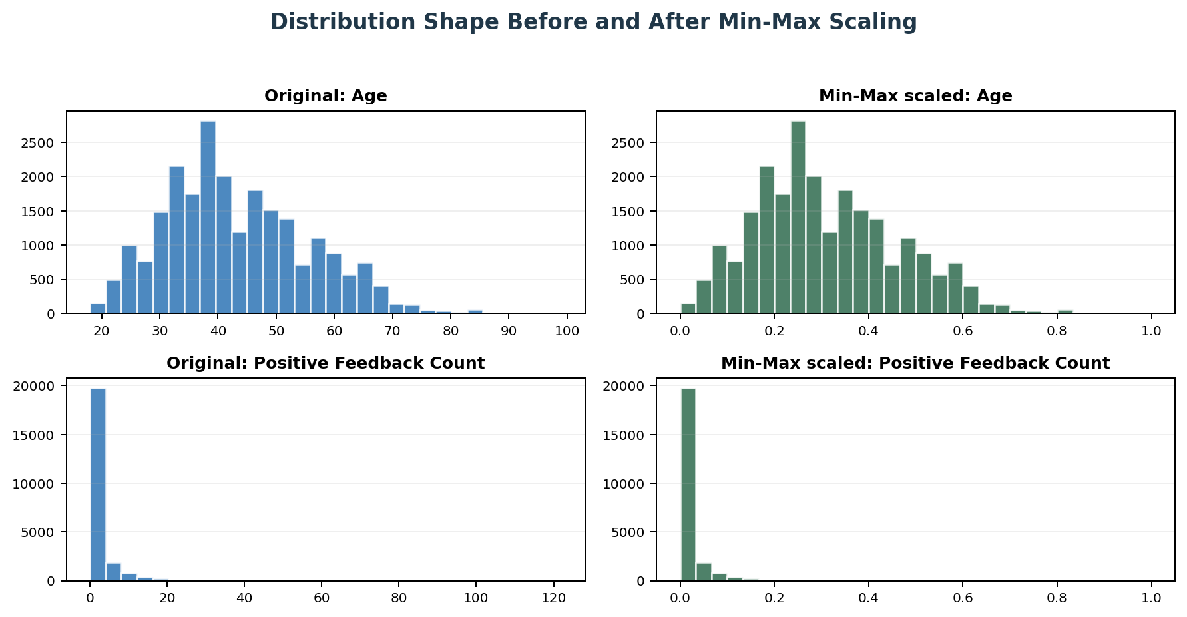
Figure 1. Min-Max scaling changes the numerical range while preserving the histogram shape.
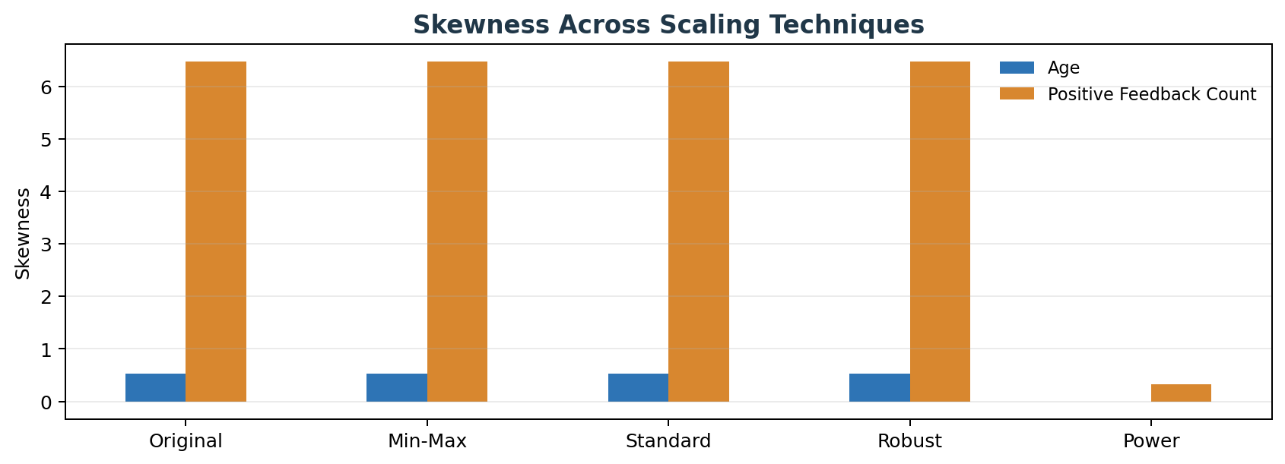
Figure 2. PowerTransformer substantially reduces skewness; linear scalers preserve it.

6. Model Evaluation
A K-Nearest Neighbors classifier with five neighbors was used because its Euclidean distance calculations are directly affected by feature scale. The target was Recommended IND. The same train/test split, model settings, and evaluation procedure were used for every method.
Metric | Role in evaluation
Accuracy | Overall proportion of correct predictions; can be misleading with imbalanced classes.
Balanced accuracy | Average recall across both target classes.
Weighted precision | Precision aggregated with support-based class weighting.
Weighted recall | Recall aggregated with support-based class weighting.
Weighted F1 | Balance of precision and recall, weighted by class support.
ROC-AUC | Ability to rank recommended observations above non-recommended observations.
Five-fold CV | Measures stability across multiple stratified training/validation partitions.

6.1 Observed selection result
Selection | Method | Evidence
Best overall model input | Original | Highest observed CV weighted F1 across original plus transformed inputs.
Best required scaler | MinMaxScaler | Highest observed CV weighted F1 among the four required scaling techniques.
Final project selection | MinMaxScaler | Meets the task requirement, preserves shape, and delivered the best scaler-based result.
The unscaled baseline outperforming the scaled variants means that scaling did not improve the chosen model on these two predictors. It does not invalidate the experiment. Instead, it demonstrates why preprocessing decisions should be tested rather than assumed. Because the task specifically required selection among the tested scalers, the original baseline was excluded from the final scaler-only ranking.

6.2 Class-imbalance caution
Approximately 82% of observations belong to the recommended class. A majority-class classifier can therefore obtain high accuracy without learning useful separation. Balanced accuracy, F1, ROC-AUC, and cross-validation were considered alongside accuracy. The generally weak separation also indicates that Age and Positive Feedback Count alone do not fully explain recommendation behavior.

7. Final Transformation
After model comparison, MinMaxScaler was fitted to the complete two-feature matrix for preparation of the final analytical export. This final full-data fit was performed only after evaluation; no model-performance scores were recomputed from the final exported file.
SELECTED METHOD MinMaxScaler transforms Age and Positive Feedback Count into the inclusive 0-1 interval and leaves all other fields unchanged.

Feature | Original range | Final range | Result
Age | 18 to 99 | 0 to 1 | Distribution shape preserved
Positive Feedback Count | 0 to 122 | 0 to 1 | Distribution shape preserved; extremes compress common values

8. Validation and Quality Checks
Check | Verified result | Status
Row count preserved | 23,486 | Pass
Column count preserved | 11 | Pass
Scaled-feature range | Both features within 0-1 | Pass
New missing values | None in scaled features | Pass
Infinite values | None | Pass
Non-scaled columns | Unchanged | Pass

9. Output Files
File | Purpose
womens_clothing_minmax_scaled.csv | Final dataset with the selected features scaled.
scaling_model_performance_comparison.csv | Held-out and cross-validation model comparison.
scaling_statistical_comparison.csv | Descriptive statistics for all tested methods.
scaler_selection_summary.csv | Recorded overall baseline and scaler-only decision.
scaling_validation_summary.csv | Final quality-control results.

10. Limitations
Only two meaningful continuous/count features were available for scaling. Clothing ID is an identifier, Rating is ordinal, and Recommended IND is binary. As a result, the predictive experiment had limited information. Model results should be interpreted as a scaler comparison rather than a high-performing recommendation system.
MinMaxScaler remains sensitive to extreme observations. Positive Feedback Count contains a small number of large values, so many common observations become concentrated near zero. RobustScaler may be preferable in a different downstream task where resistance to extremes matters more than the observed KNN score.
PowerTransformer improved symmetry most strongly but changed the original distribution. Its lower observed model ranking shows that improved normality did not translate into better KNN performance in this experiment.

11. Final Conclusion
The project successfully tested MinMaxScaler, StandardScaler, RobustScaler, and PowerTransformer on Age and Positive Feedback Count. Each method was fitted in a leakage-safe workflow, compared statistically, and evaluated through a consistent KNN classification experiment with stratified cross-validation.
The original unscaled input achieved the best overall model result and was retained as an analytical baseline. Among the four required scaling techniques, MinMaxScaler ranked first on the observed scaler-only comparison. It was selected because it provided the strongest model result among the required methods while preserving the original distribution shapes and converting both features to a consistent 0-1 range.
Final validation confirmed that the transformation preserved all 23,486 rows and 11 columns, introduced no missing or infinite values in the scaled features, and left all non-scaled columns unchanged. The feature-scaling task is therefore complete and ready for academic submission.
PROJECT STATUS Completed and validated. Final selected scaling technique: MinMaxScaler.

Appendix A. Reproducible Core Workflow
X = df[['Age', 'Positive Feedback Count']]
y = df['Recommended IND']
X_train, X_test, y_train, y_test = train_test_split(..., stratify=y)
pipeline = Pipeline([('scaler', MinMaxScaler()), ('model', KNeighborsClassifier(5))])
pipeline.fit(X_train, y_train)
final_scaled_df[scaling_features] = MinMaxScaler().fit_transform(df[scaling_features])

Appendix B. Key Terms
Term | Definition
Data leakage | Use of test or validation information during preprocessing or training.
IQR | Interquartile range: Q3 minus Q1; robust measure of spread.
Skewness | Measure of distribution asymmetry.
Cross-validation | Repeated validation across multiple train/validation folds.
Baseline | Reference result used to judge whether a transformation helps.

